John von Neumann was a visionary mathematician, computer scientist, and one of the most impactful minds in math, economics, and logic. It was his ability to remember and calculate—equations by the age of six, calculus by eight. By 23, he held a Ph. He had many breakthroughs, including as an M. D., but his biggest breakthrough related to computer architecture. Until his work, computers could only execute one task at any moment and required rewiring for every new job. Von Neuman architecture enabled the same machine to be capable of handling many tasks — simply by loading a new program rather than re-configuration. In this paper, we will detail his architecture, break it down, and discuss the relevance of all three to modern computing.

At the heart of most modern computing systems lies the von Neumann architecture prominent for its “stored-program” concept. In comparison with early computers where data and instructions were held in separate memories, both were kept in a single memory space in von Neumann's design. It generalized the computer into a device capable of running many tasks (by simply changing its program) without the necessity of hardware change (von Neumann, 1945). Originally created back in 1945 at the Institute for Advanced Study in Princeton, this model transformed computing from machines with a single purpose to systems that were able to be reprogrammed, and which still represent the architecture of most computers today.

Basic Elements of the Von Neumann Architecture

The architecture itself has four basic components: the Central Processing Unit (CPU), memory (also called main memory, or RAM), input/output, I/O devices, and the system bus that connects them. About — The processor is the CPU that executes instructions in memory and consists of two components: the ALU (Arithmetic Logic Unit) which performs math and logic functions, and the CU (Control Unit) which fetches each instruction and decodes them. Collectively, they facilitate fast executions in a well-functioning system (Burks et al., 1946).

In the von Neumann model, memory provides a common space for instructions and data; simple but flexible. But this design has a limitation called von Neumann bottleneck which can slow the CPU down when it is waiting on data from memory. Some contemporary systems have mitigated this problem through memory hierarchies with caches that place hot data in proximity to the CPU hence speeding up processing (Parker 1996).

I/O devices allows the computer to communicate with world outside it. Input Devices, such as keyboards and mice are used to send data to the computer and Output devices output results from The System Performance measure of an Information system, its ability to handle a relatively large workload with low latency within acceptable limits. The bus system (part of the architecture of von Neumann) performs as a communication pipe which connects CPU, memory and I/O devices (Parker, 1996).

Since then, computer design has continuously improved on the von Neumann architecture that forms its bedrock to keep up with the increasing speed of technology. This model, augmented with newer techniques such as cache memory and out-of-order execution to mitigate performance bottlenecks and provide a way to schedule complex operations while managing long delays (Parker 1996), still finds use in modern desktops, laptops, and mobile devices.

Although there are alternative models, such as the Harvard architecture model, the von Neumann model is most commonly used because of its simplicity and generality. It influenced hardware and software development by suggesting the storage of programs in memory for execution by the CPU, laying foundations for operating systems, compiler construction, and even modern programming languages (Burks, Goldstine, & von Neumann, 1946).

The stored-program idea of one John von Neumann provided the basis for general-purpose computers that today define our world. The shared memory for instructions and data in his architecture, along with its adaptive nature, helps push the technology frontier. Though modern day systems have built upon this original framework, the von Neumann model is still at the heart of computing. For decades to come, its principles will shape what we can do with AI, quantum computing, and machine learning.

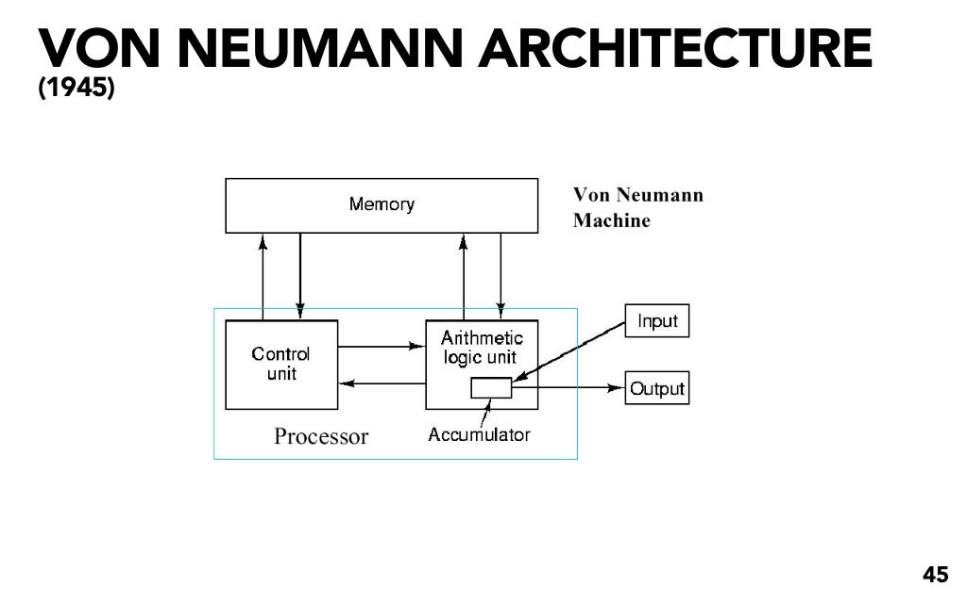

References:

Burks, A. W., Goldstine, H. H., & von Neumann, J. (1946). *Preliminary discussion of the logical design of an electronic computing instrument*. Princeton University.

Parker, D. (1996). *The von Neumann architecture*. Cambridge University Press.

von Neumann, J. (1945). *First draft of a report on the EDVAC*.